**Project Planning Phase**

**Project Planning Template (Product Backlog, Sprint Planning, Stories, Story points)**

| Date | 18 October 2022 |
| --- | --- |
| Team ID | PNT2022TMID36001 |
| Project Name | Smart Lender - Applicant Credibility Prediction for Loan Approval |
| Maximum Marks | 8 Marks |

**Product Backlog, Sprint Schedule, and Estimation (4 Marks)**

| **Sprint** | **Functional Requirement (Epic)** | **User Story Number** | **User Story / Task** | **Story Points** | **Priority** | **Team Members** |
| --- | --- | --- | --- | --- | --- | --- |
| Sprint-1 | Registration | USN-1 | As a user, I can register for the application by entering my email, password, and confirming my password. | 2 | High | Praveen Kumar V  Deekshetha |
| Sprint-1 | Registration | USN-2 | As a user, I will receive confirmation email once I have registered for the application | 1 | Medium | Nandhini V |
| Sprint-1 | Registration | USN-3 | As a user, I can register for the application through Facebook | 1 | Medium | Nivedha N |
| Sprint-1 | Registration | USN-4 | As a user, I can register for the application through Gmail | 1 | Medium | Harish B |
| Sprint - 2 | Login | USN-5 | As a user, I can log into the application by entering email & password | 1 | Medium | Deekshetha |
| Sprint - 2 | Dashboard | USN-6 | As a user, I should be able to experience a smooth user interface | 1 | Medium | Nivedha N  Nandhini V |
| Sprint - 2 | Dataset Collection and preprocessing | USN-7 | All necessary and legal data for loan approval check should be collected and preprocessed | 2 | High | Praveen Kumar V  Harish B  Deekshetha |
| Sprint - 3 | Model building and training | USN-8 | Suitable model that could be trained and tested with accurate performance has to built | 2 | High | Nivedha N  Praveen Kumar V Nandhini V |
| Sprint - 3 | Model testing and Prediction | USN-9 | Model that is built should be tested, predicted and accuracy is noted. Improvements in accuracy should also be made. | 2 | High | Harish B  Deekshetha |
| Sprint - 4 | Integration | USN-10 | Integrate frontend and backend using flask server and deploy in IBM cloud | 1 | Medium | Praveen Kumar V  Harish B |
| Sprint - 4 | Testing | USN-11 | Overall application is tested for deployment | 2 | High | Nivedha N  Deekshetha  Nandhini V |

**Project Tracker, Velocity & Burndown Chart: (4 Marks)**

| **Sprint** | **Total Story Points** | **Duration** | **Sprint Start Date** | **Sprint End Date (Planned)** | **Story Points Completed (as on Planned End Date)** | **Sprint Release Date (Actual)** |
| --- | --- | --- | --- | --- | --- | --- |
| Sprint-1 | 20 | 6 Days | 24 Oct 2022 | 29 Oct 2022 | 20 | 29 Oct 2022 |
| Sprint-2 | 20 | 6 Days | 31 Oct 2022 | 05 Nov 2022 | 20 | 05 Nov 2022 |
| Sprint-3 | 20 | 6 Days | 07 Nov 2022 | 12 Nov 2022 | 20 | 12 Nov 2022 |
| Sprint-4 | 20 | 6 Days | 14 Nov 2022 | 19 Nov 2022 | 20 | 19 Nov 2022 |

**Velocity:**

Imagine we have a 10-day sprint duration, and the velocity of the team is 20 (points per sprint). Let’s calculate the team’s average velocity (AV) per iteration unit (story points per day)

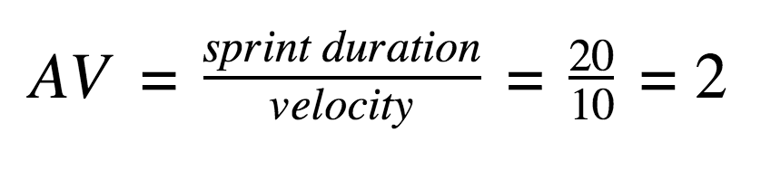

**Burndown Chart:**

A burndown chart is a graphical representation of work left to do versus time. It is often used in agile[software development](https://www.visual-paradigm.com/scrum/what-is-agile-software-development/) methodologies such as [Scrum](https://www.visual-paradigm.com/scrum/scrum-in-3-minutes/). However, burn down charts can be applied to any project containing measurable progress over time.

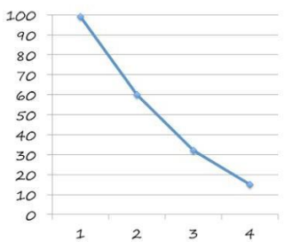

Working

hours

Total sprints